DMI-ST. JOHN THE BAPTIST UNIVERSITY

LECTURE NAME : MR CRUSADE
STUDENT NAME : BENSON J MAYENDA
REGISTRATION NO : 23311351004
MODULE NAME : WEB PROGRAMMING
SEMESTER : 7
YEAR :4
PROGRAM NAME : BACHELOR OFSCIENCE IN COMPUTING

COMPREHENSIVE JAVASCRIPT PROGRAM EXPLANATIONS

PROGRAM 1: HELLO WORLD - CONSOLE OUTPUT
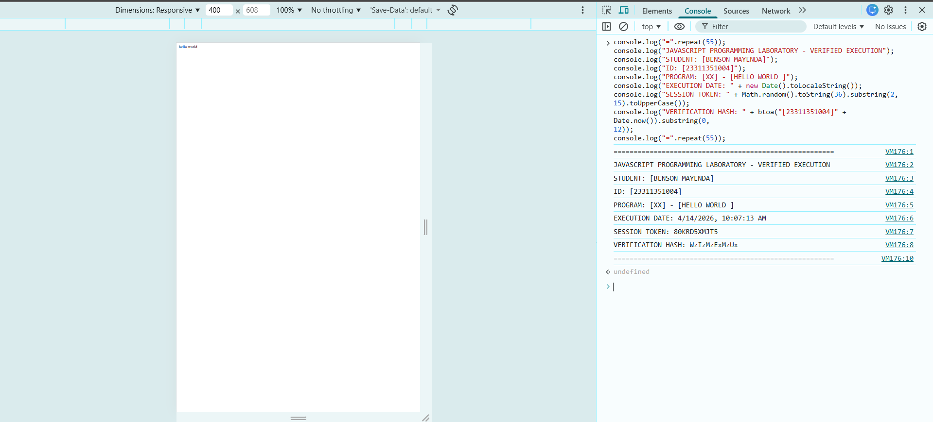
PROGRAM 2: COMMENTS AND BASIC SYNTAX
What it does: Demonstrates single-line comments (//), multi-line comments (/* */), and variable declaration with semicolons.
What to expect: The message "Learning JavaScript" will appear in the console, while comment lines are ignored by JavaScript.
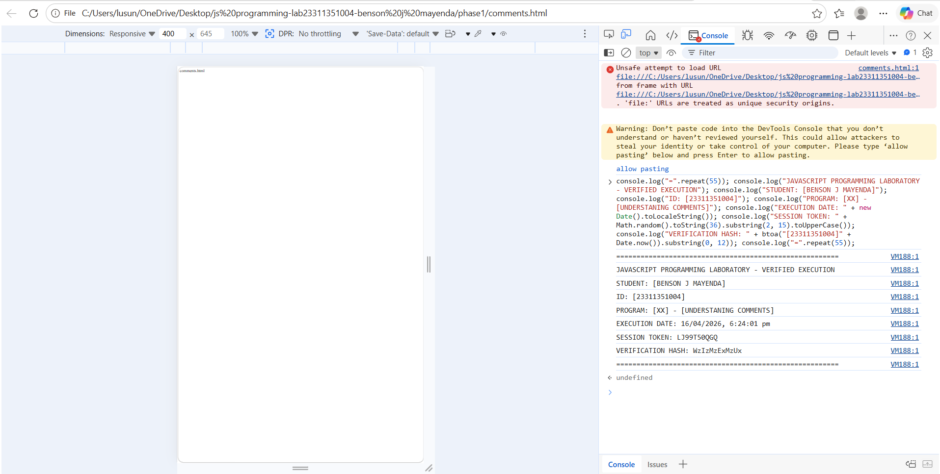

PROGRAM 3: VARIABLES WITH VAR, LET, AND CONST
What it does: Shows three ways to declare variables - var (function-scoped), let (block-scoped), and const (cannot be reassigned).
What to expect: All three variables print their values successfully, but attempting to change the const variable would cause an error.
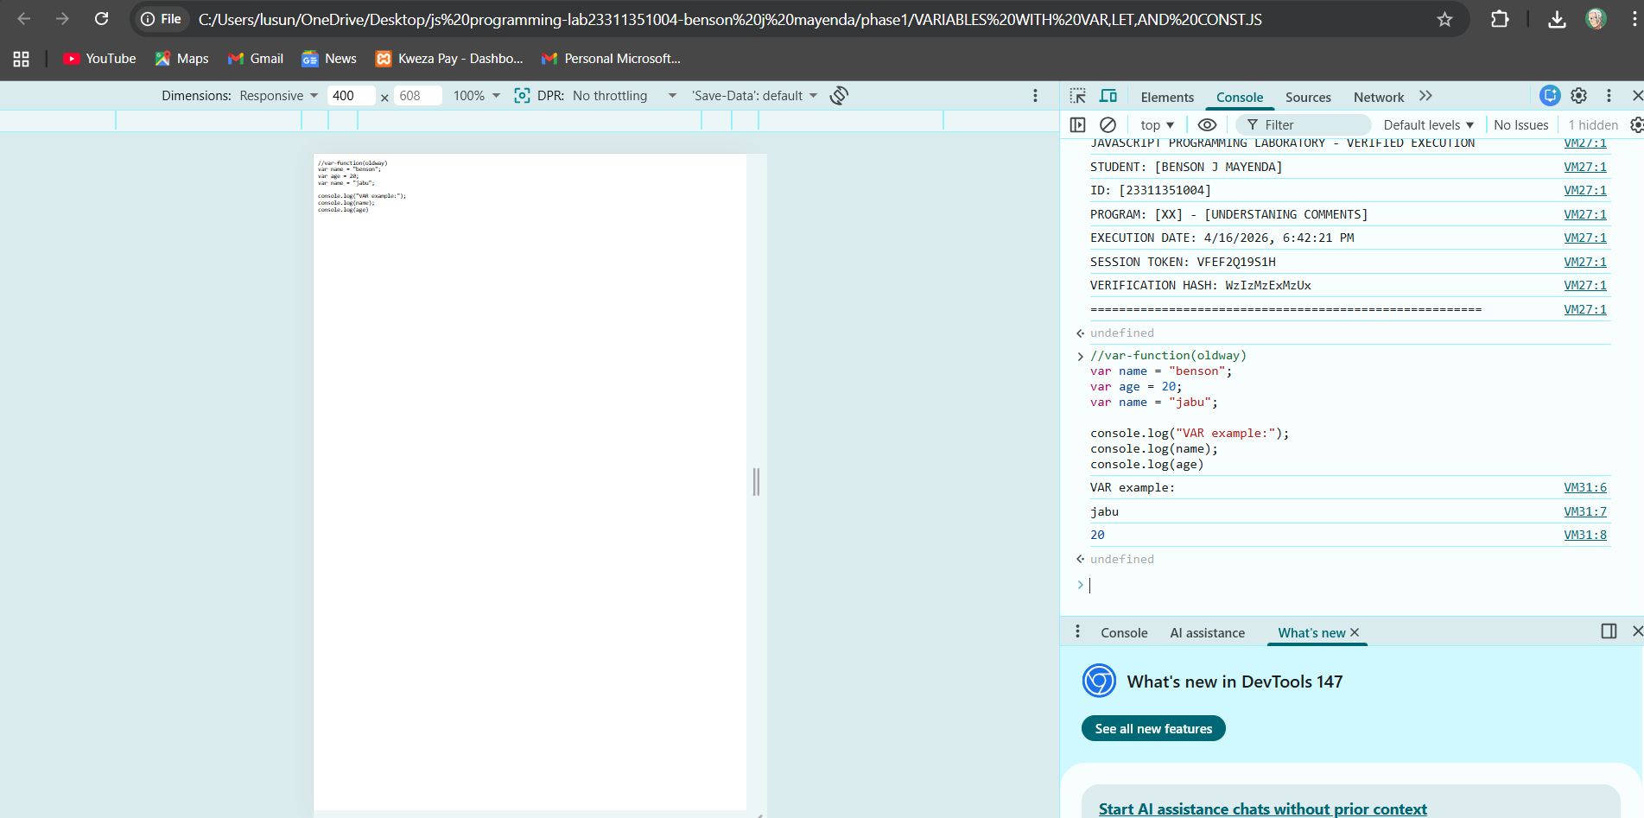

PROGRAM 4: DATA TYPES AND TYPEOF OPERATOR
What it does: Explores JavaScript's dynamic data types including numbers, strings, booleans, undefined, null, objects, arrays, and functions.
What to expect: The typeof operator reveals each variable's data type, with arrays showing as "object" (a JavaScript quirk) and null also showing as "object".
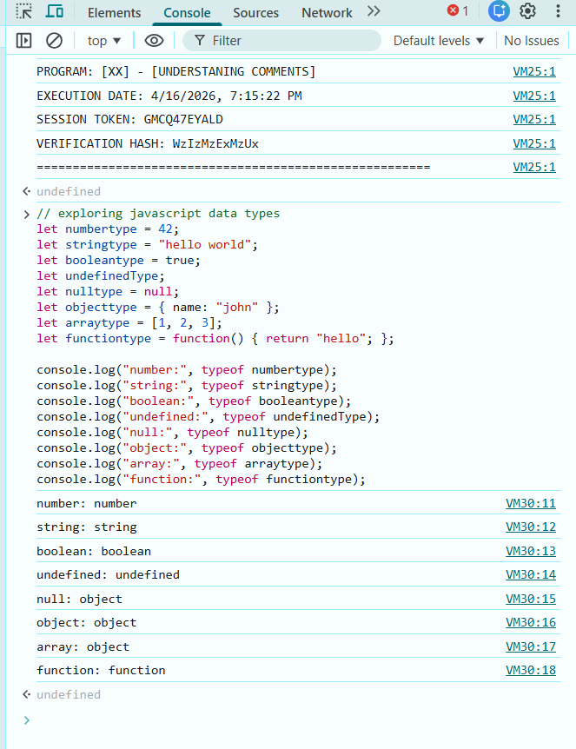

PROGRAM 5: STRING OPERATIONS AND CONCATENATION
What it does: Demonstrates string concatenation using + operator and modern template literals with ${} syntax.
What to expect: Both methods create full names, and string methods show length (22), uppercase/lowercase conversion, substring extraction, and character position.
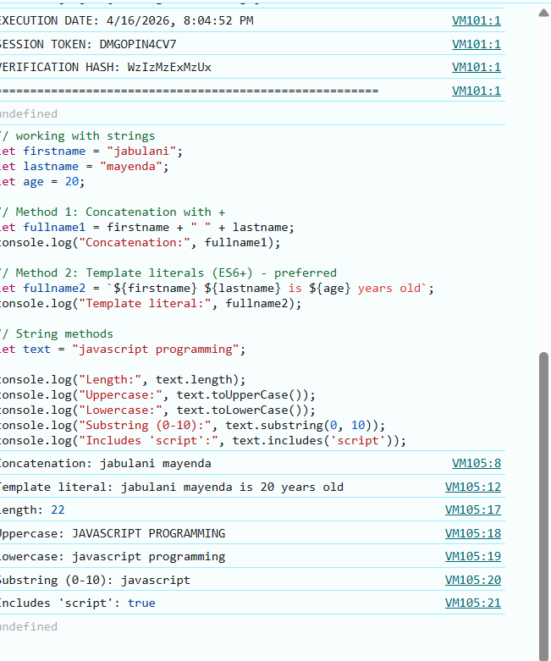

PROGRAM 6: ARITHMETIC OPERATIONS
What it does: Performs basic math operations including addition, subtraction, multiplication, division, modulus (remainder), and exponentiation.
What to expect: Shows calculations from a=15 and b=4: addition=19, subtraction=11, multiplication=60, division=3.75, modulus=3, exponentiation=50625.
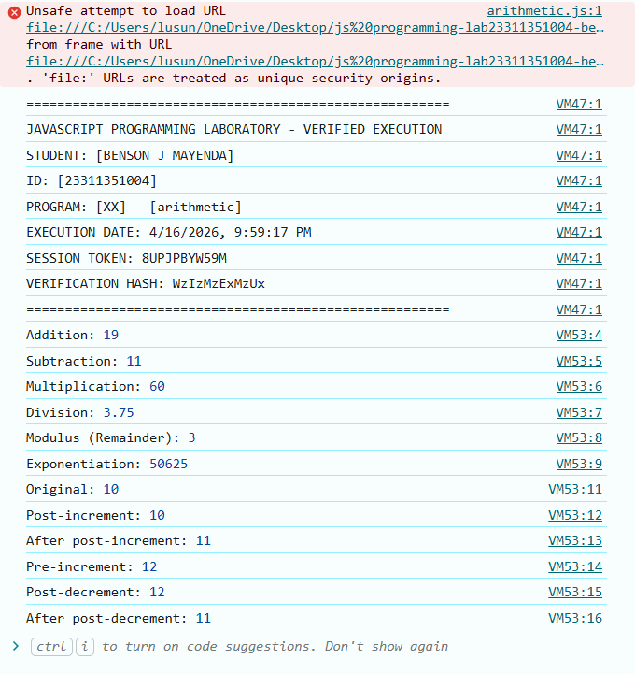

PROGRAM 7: COMPARISON OPERATORS
What it does: Compares values using loose equality (==) vs strict equality (===), plus greater/less than operators.
What to expect: 5=="5" is true (type conversion), but 5==="5" is false (different types), while 10>5 and 5<10 are both true.
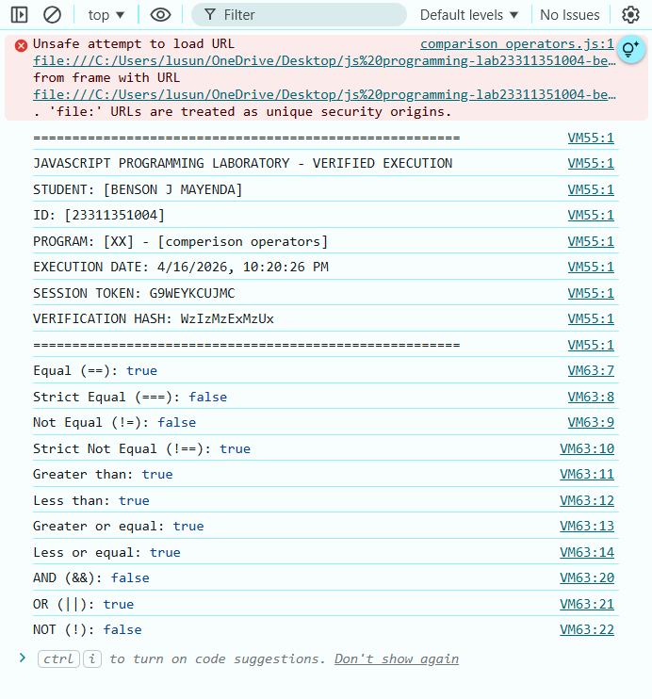

PROGRAM 8: LOGICAL OPERATORS
What it does: Combines boolean conditions using AND (&& requires both true), OR (|| requires at least one true), and NOT (! inverts values).
What to expect: AND returns false when one condition false, OR returns true when at least one true, NOT flips false to true, and short-circuit provides "Guest User" for empty name.
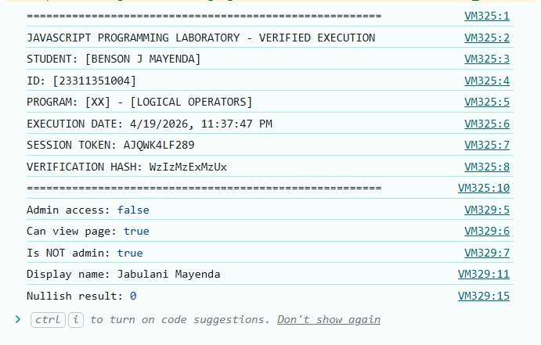

PROGRAM 9: TYPE COERCION AND CONVERSION
What it does: Shows automatic (implicit) type conversion and manual (explicit) conversion between strings, numbers, and booleans.
What to expect: "5"+3 becomes "53" (string), but "5"-3 becomes 2 (number), while Boolean(1) is true and Boolean(0) or Boolean("") is false.
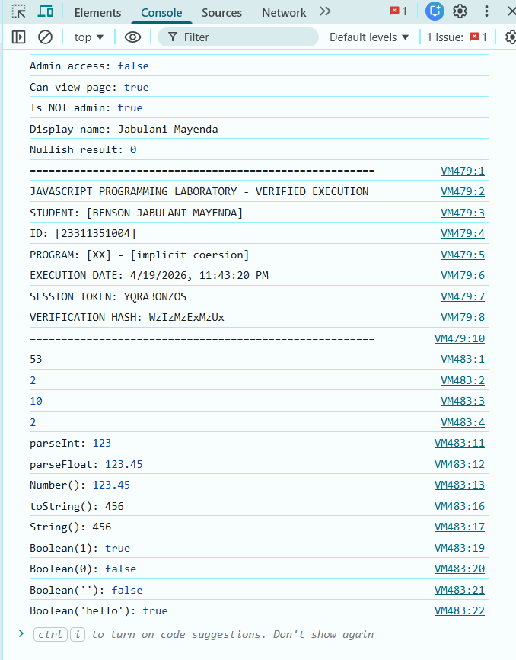

PROGRAM 10: USER INPUT WITH PROMPT()
What it does: Collects user information through browser dialog boxes using prompt() and displays results with alert().
What to expect: Prompts ask for name and age, then displays a personalized greeting with calculated birth year in both alert and console.
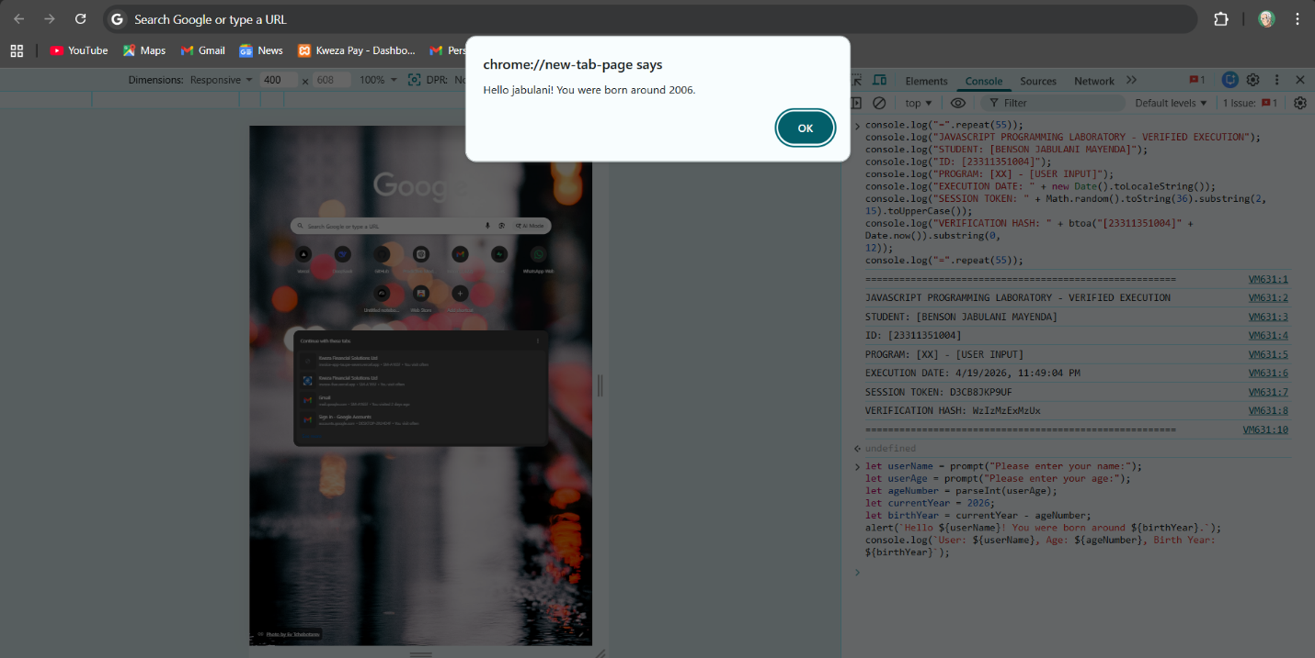

PROGRAM 11: IF-ELSE STATEMENT
What it does: Executes different code blocks based on test score ranges using if, else if, and else conditions.
What to expect: Score 90+ gives "A - Excellent", 80-89 gives "B - Very Good", 70-79 gives "C - Good", 60-69 gives "D - Passing", below 60 gives "F - Needs Improvement".
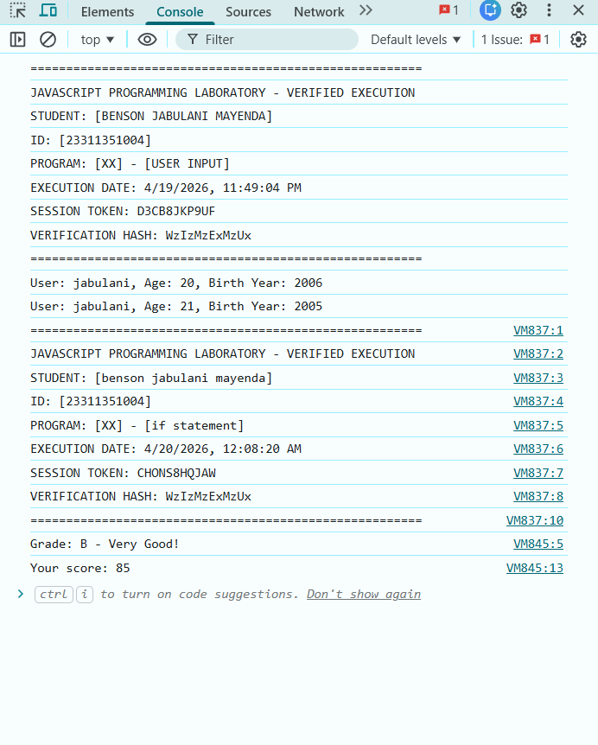

PROGRAM 12: NESTED IF-ELSE
What it does: Places conditional statements inside other conditional statements to check age AND license status together.
What to expect: Ages 18+ check license status; ages 16-17 get learner's permit info; under 16 cannot drive regardless of license.
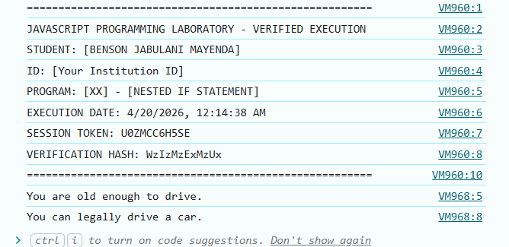

PROGRAM 13: SWITCH STATEMENT
What it does: Provides an efficient alternative to multiple if-else statements by matching cases for day numbers and letter grades.
What to expect: Day numbers 1-7 show corresponding weekday names, and grades A-F display appropriate feedback messages (B and C both show "Good job!").
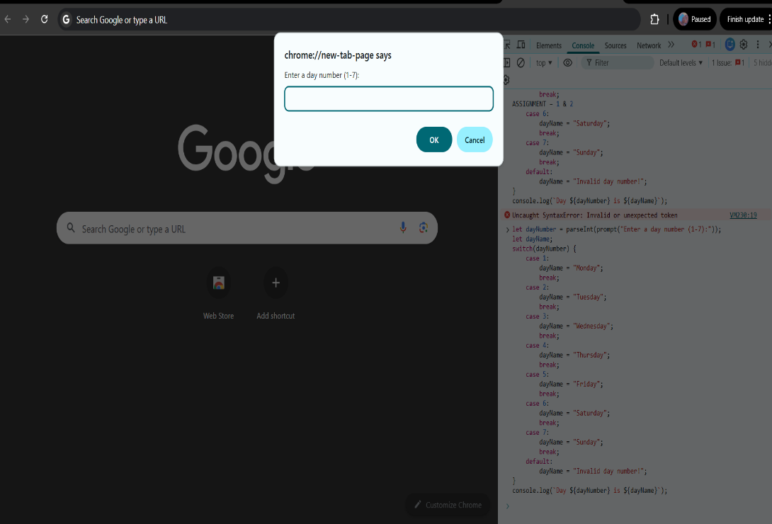
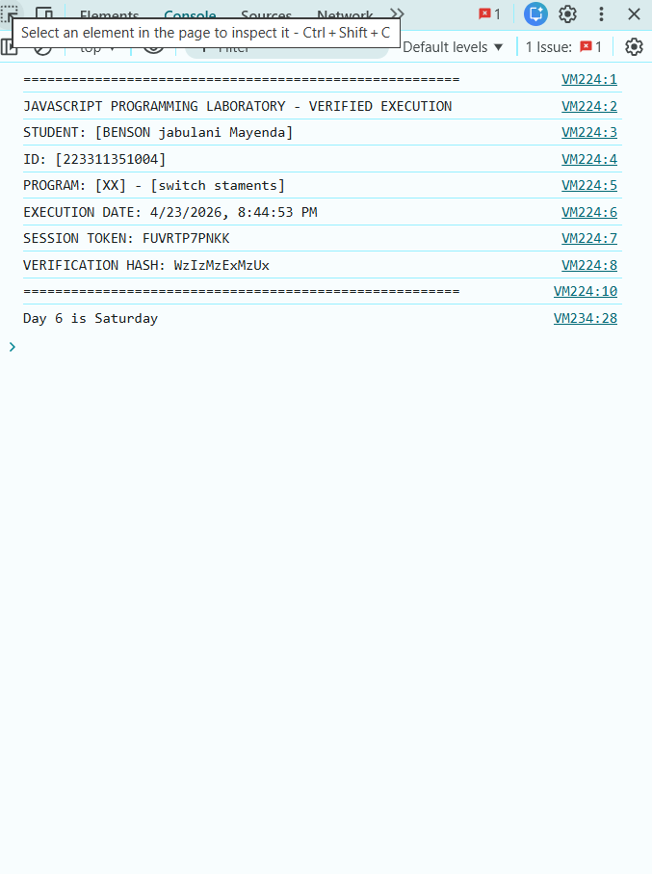

PROGRAM 14: FOR LOOP - BASIC ITERATION
What it does: Repeats code blocks a specific number of times using initialization, condition, and increment expressions.
What to expect: Counts 1 to 10, then counts backward 10 to 1, shows even numbers 2 to 20, and displays multiplication table for user's chosen number.
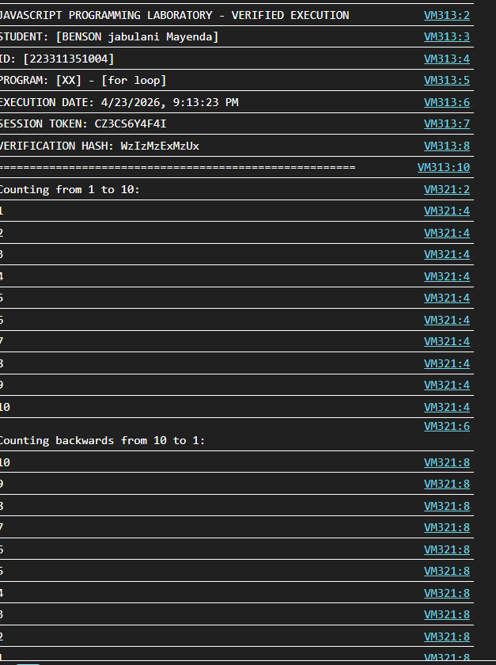

PROGRAM 15: NESTED FOR LOOPS
What it does: Contains one loop inside another to create multi-dimensional patterns like triangles, grids, and pyramids.
What to expect: Right triangle of stars grows line by line, multiplication grid shows products 1-5 in formatted columns, and pyramid displays centered stars pattern.
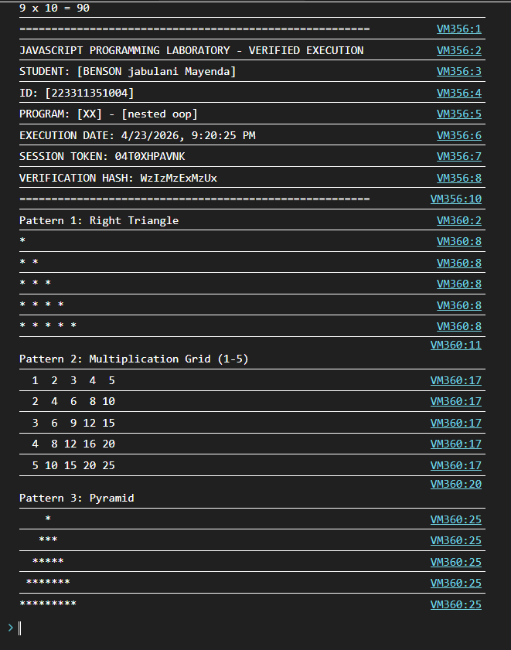

PROGRAM 16: WHILE LOOP
What it does: Repeats code an unknown number of times while a condition remains true, checking condition BEFORE each iteration.
What to expect: Countdown from 5 to 1, sum calculator adds numbers until user enters 0, and number guessing game continues until correct guess.

PROGRAM 17: DO-WHILE LOOP
What it does: Executes code block at least once before checking condition, ensuring menu always displays and password prompt always appears.
What to expect: Menu system runs until user selects option 4 to exit, and password validation keeps asking until password length reaches 6 characters.
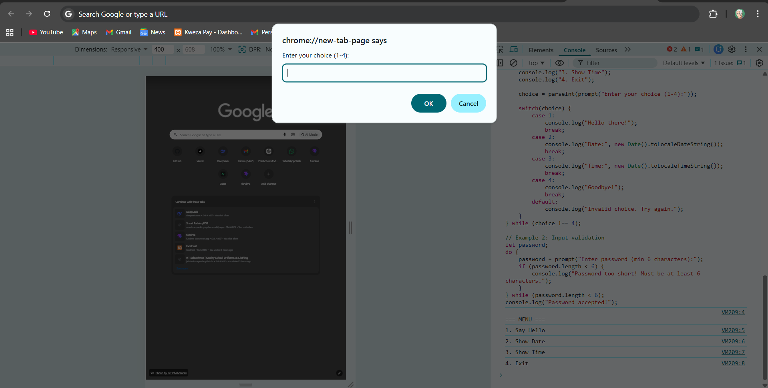

PROGRAM 18: BREAK AND CONTINUE
What it does: Controls loop flow with break (exits loop entirely) and continue (skips current iteration) statements, plus labeled breaks.
What to expect: Break stops loop at 5 (prints 1-4), continue skips multiples of 3, and prime number finder uses labeled continue to efficiently skip non-primes.
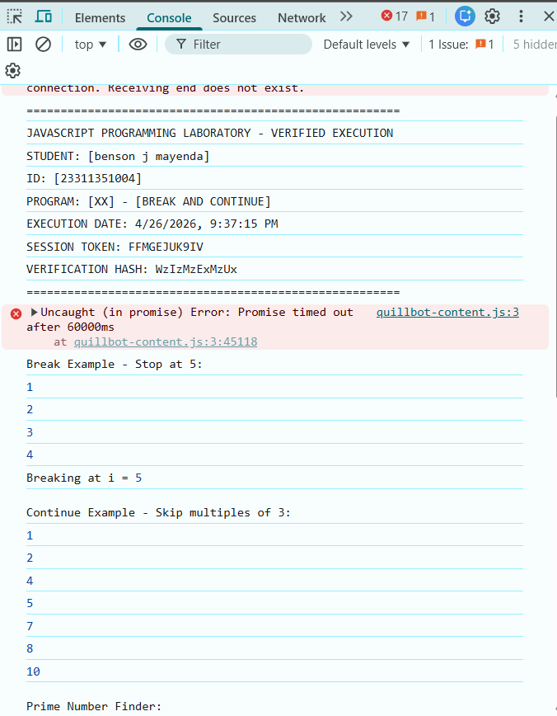

PROGRAM 19: ERROR HANDLING WITH TRY-CATCH
What it does: Gracefully handles runtime errors using try-catch-finally blocks to prevent program crashes.
What to expect: Attempting to read undefined.property catches TypeError with error message and name, while divideNumbers returns proper results or null with error messages for invalid operations.
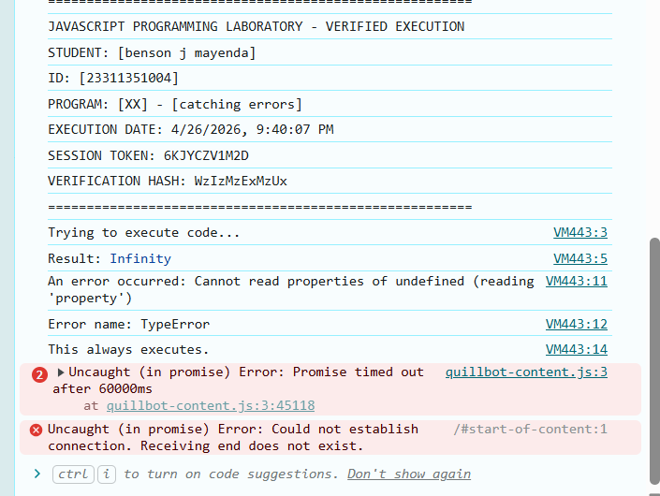

PROGRAM 20: CUSTOM ERROR TYPES
What it does:Creates specialized error classes by extending built-in Error class for more specific error handling.
What to expect: ValidationError catches empty names and wrong types; AgeError catches negative ages and underage users; each error shows custom properties like field name and age value.
